**Login Testing Documentation**

1. Login Timestamp Testing
   1. Database Before Login

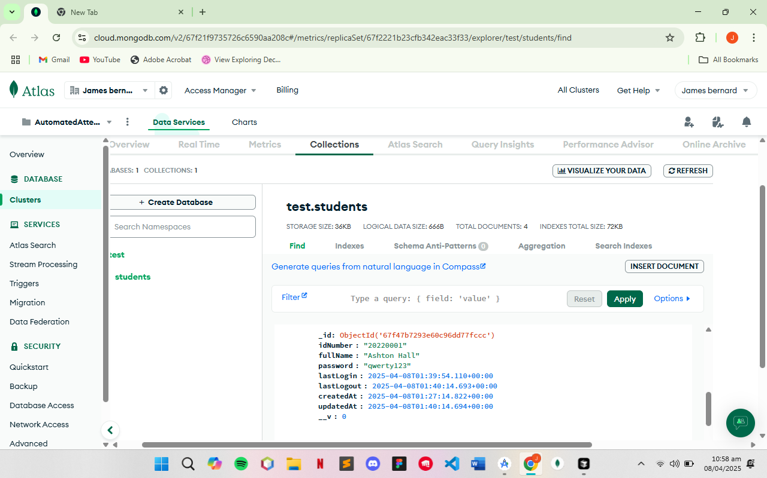

* 1. Database After Login

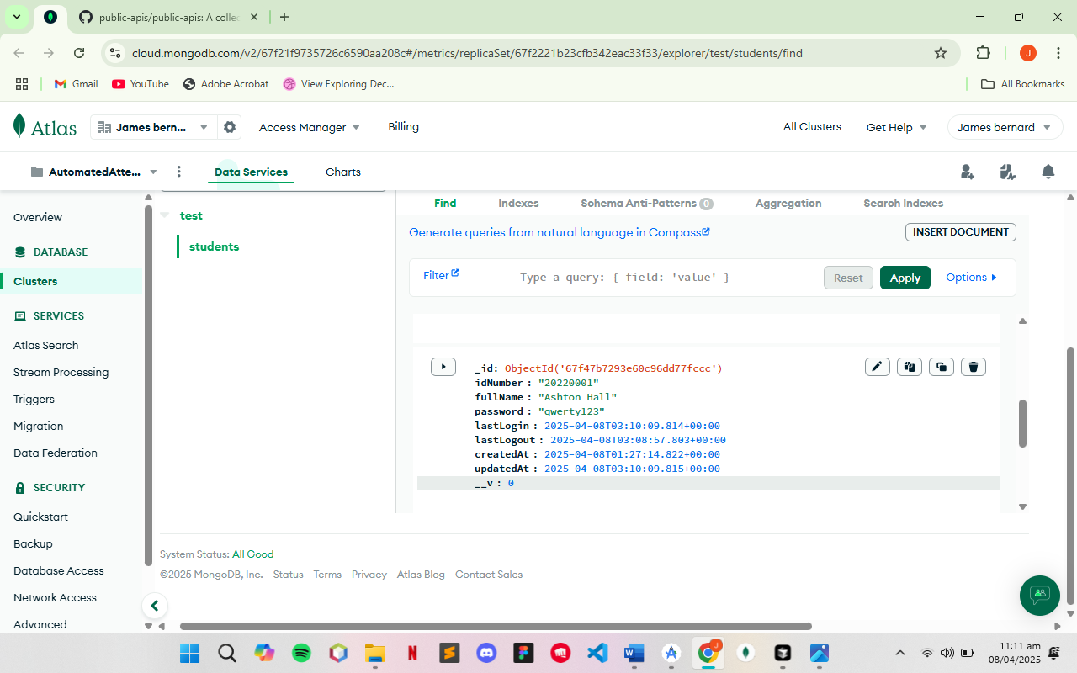

1. Login Testing
   1. Entering Wrong Credentials

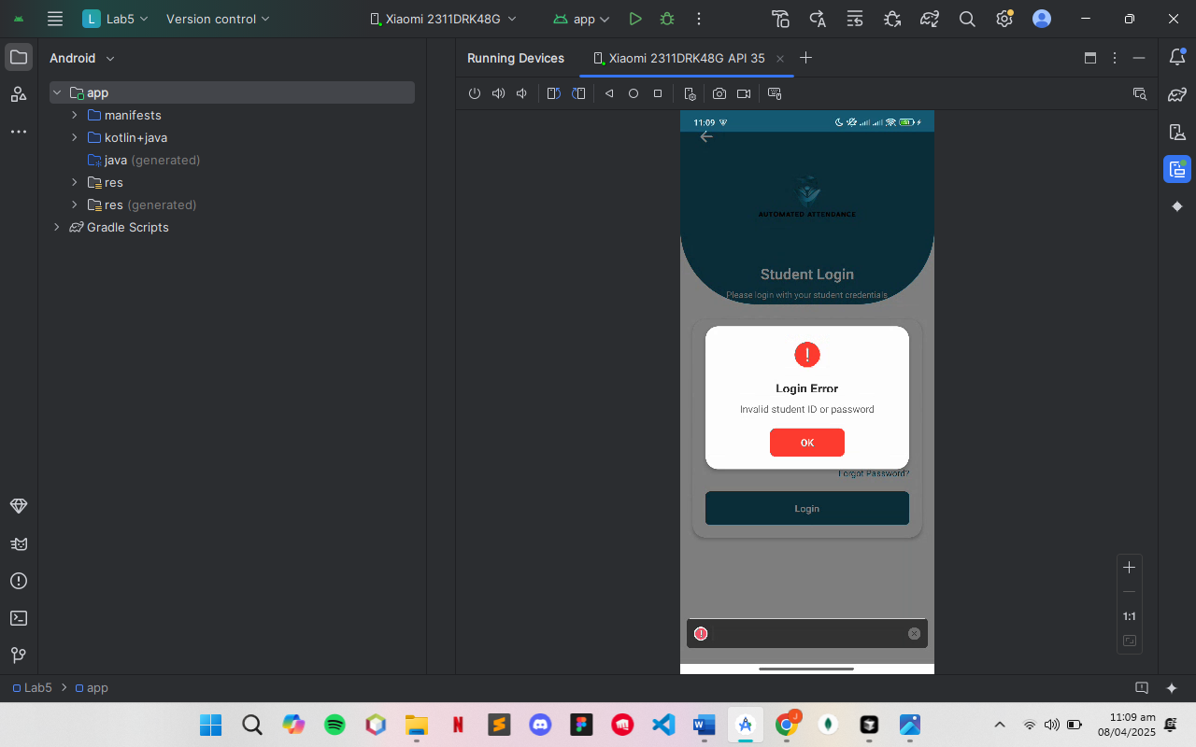

* 1. Entering Correct Credentials

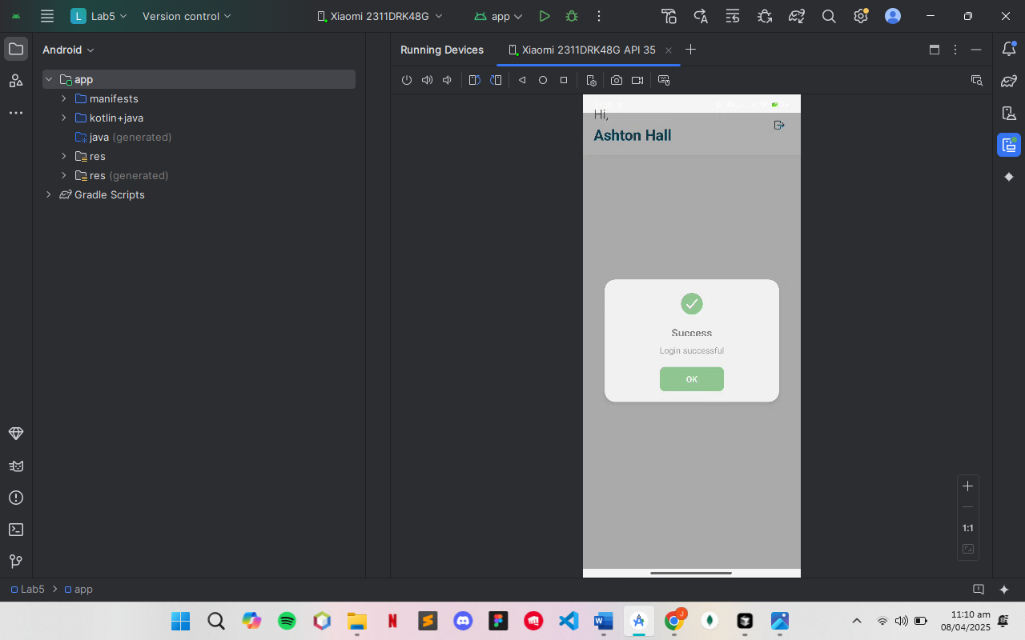

1. Login Screen

